Saunder, Greg (from Linked In)

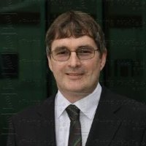

HSC Warragul High School 1975–1980. B.Sc. (Forestry) ANU 1981-1984. Grad Dip Business Admin, Administration University of South Australia 2011.

Senior Forester Auspine Limited 1990–2000. Manager Opearations - Green Triangle ForestrySA 2008–2010 Mount Gambier. General Manager - Operations ForestrySA 2010 – .

